Item | Description
Algorithm Type | Regression
Learning Type | Supervised
Target Variable | Continuous
Parametric | Yes
Linear / Non-linear | Linear
Interpretability | Excellent
Feature Importance | Coefficient magnitude
Scikit-learn Class | LinearRegression()
statsmodels Class | OLS()

Simple Linear Regression tries to find the best fitting straight line that explains the relationship between one independent variable (X) and one dependent variable (Y).
The objective is to minimize the total squared prediction error between the observed and predicted values.
It answers questions such as:
- How does house price change with area?
- How does salary change with years of experience?
- How does fuel consumption change with vehicle weight?

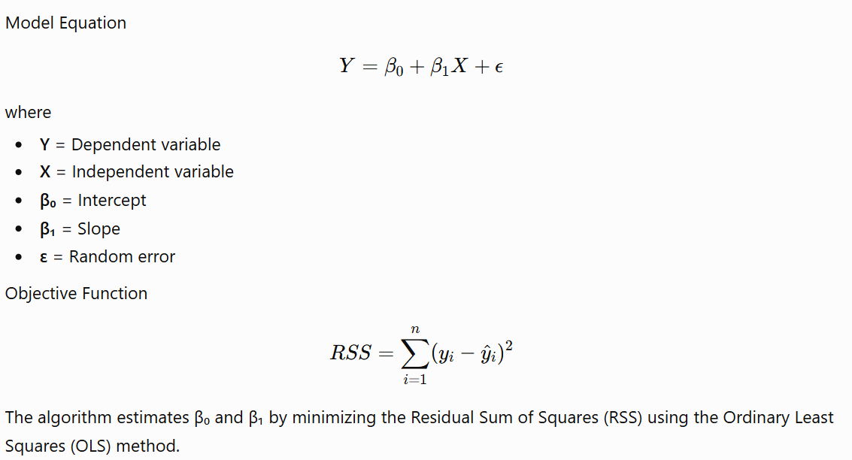
Assumptions
- Linear relationship between X and Y
- Independent observations
- Residuals have constant variance (Homoscedasticity)
- Residuals are normally distributed (primarily for inference)
- No significant outliers

Characteristic | Effect
Scaling | Recommended, especially when comparing coefficients or extending to regularized models
Outliers | Highly sensitive
Missing Values | Must be handled before fitting
Categorical Variables | Require encoding (e.g., one-hot encoding)
Multicollinearity | Not applicable (only one predictor)
Feature Importance | Coefficient value (β₁)
Interpretability | Excellent
Computational Complexity | O(n) for one predictor (more generally O(np²) for OLS with p predictors)
Prediction Speed | Very fast

When to Use
- One continuous predictor and one continuous target
- Relationship appears approximately linear
- High interpretability is important
- Baseline model for regression tasks

MULTIPLE LINEAR REGRESSION

Item | Description
Algorithm Type | Regression
Learning Type | Supervised
Target Variable | Continuous
Predictors | Two or more
Parametric | Yes
Linear / Non-linear | Linear
Interpretability | Excellent
Feature Importance | Regression coefficients
Handles Multiple Features | Yes
Main Objective | Predict a continuous variable using multiple predictors

Multiple Linear Regression extends Simple Linear Regression by using multiple independent variables to predict a single continuous dependent variable.
Instead of finding the best-fitting line, it finds the best-fitting hyperplane in a multi-dimensional feature space.

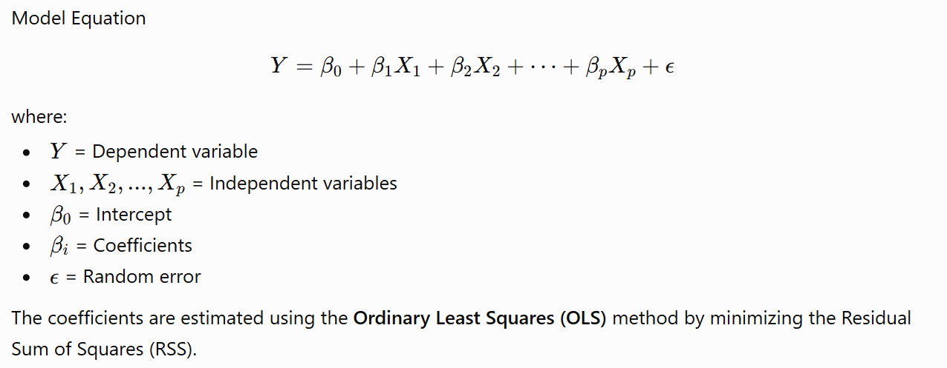

Multiple Linear Regression relies on several assumptions:
- Linear relationship between predictors and the target.
- Independent observations.
- Homoscedasticity (constant variance of residuals).
- Residuals are approximately normally distributed (important for statistical inference).
- No perfect multicollinearity among predictors.
- Errors are independent.

Characteristic | Effect
Scaling | Recommended (essential if using regularized versions later)
Outliers | Highly sensitive
Missing Values | Must be imputed or removed before fitting
Categorical Variables | Must be encoded (e.g., one-hot encoding)
Multicollinearity | Can inflate coefficient estimates and reduce interpretability
Feature Importance | Coefficient magnitude and sign (after considering feature scales)
Interpretability | Excellent
Prediction Speed | Very fast

Overfitting
Causes
- Too many predictors relative to the number of observations.
- Inclusion of irrelevant or noisy features.
- Highly correlated predictors.
- Overly complex interaction terms or polynomial features.
How to Reduce It
- Remove irrelevant variables.
- Increase the amount of training data.
- Use cross-validation.
- Apply feature selection.
- Consider regularization (Ridge, Lasso, ElasticNet) when appropriate
Model evaluation metrics

R²: Proportion of variance explained.
Adjusted R²: Adjusts R² for the number of predictors, helping compare models with different feature counts.
MAE (Mean Absolute Error): Average absolute prediction error.
MSE (Mean Squared Error): Average squared prediction error.
RMSE (Root Mean Squared Error): Square root of MSE, in the same units as the target.

Multicollinearity
Symptoms
- Large changes in coefficients with small changes in data.
- High standard errors.
- Significant overall model but insignificant individual predictors.
Detection
- Correlation matrix.
- Variance Inflation Factor (VIF).
  - VIF < 5: Usually acceptable.
  - VIF 5–10: Investigate.
  - VIF > 10: Strong multicollinearity.
Solutions
- Remove redundant predictors.
- Combine correlated variables.
- Use Ridge or Lasso Regression or ElasticNet.

Categorical regression

Item | Description
Algorithm Type | Regression
Learning Type | Supervised
Target Variable | Continuous
Predictors | Numerical + Categorical
Parametric | Yes
Linear / Non-linear | Linear
Interpretability | Excellent
Feature Importance | Regression coefficients
Main Challenge | Converting categories into numerical variables

Many real-world datasets contain categorical variables such as:
- Gender
- City
- Education
- Department
- Marital Status
- Product Category
Since linear regression works only with numbers, these categories must be converted into numerical form.
The most common technique is Dummy Variable Encoding (One-Hot Encoding).
The regression model then estimates how much each category changes the target variable compared with a chosen reference category.

Suppose
Department has three categories:
- HR
- Sales
- IT
Using HR as the reference category:
$$Salary=β_{0}+β_{1}Experience+β_{2}Sales+β_{3}IT+ϵ$$
Where
Sales
- 1 → Sales
- 0 → Otherwise
IT
- 1 → IT
- 0 → Otherwise
HR
- Both dummy variables are 0
Interpretation
β₂ is the Average salary difference between Sales and HR
β₃ is the Average salary difference between IT and HR

Same assumptions as Multiple Linear Regression:
- Linear relationship.
- Independent observations.
- Homoscedasticity.
- Normally distributed residuals (for inference).
- No perfect multicollinearity.

Characteristic | Effect
Scaling | Recommended for numerical features only (especially if extending to regularized models)
Outliers | Highly sensitive
Missing Values | Must be handled before fitting
Numerical Variables | Directly supported
Categorical Variables | Must be encoded
Dummy Variable Trap | Must be avoided
Feature Importance | Regression coefficients
Interpretability | Excellent

Overfitting
Causes
- Too many categorical levels.
- High-cardinality features (e.g., thousands of ZIP codes).
- Too many irrelevant dummy variables.
- Small sample sizes for certain categories.
How to Reduce It
- Merge infrequent categories into an "Other" group.
- Remove irrelevant categorical variables.
- Apply Ridge, Lasso, or ElasticNet if many encoded features are present.
- Ensure each category has sufficient observations

L2 regularization

Item | Description
Algorithm Type | Regression
Learning Type | Supervised
Target Variable | Continuous
Parametric | Yes
Linear / Non-linear | Linear
Regularization | L2 (Ridge Penalty)
Interpretability | High
Feature Selection | No
Main Objective | Reduce overfitting and multicollinearity while retaining all predictors

Multiple Linear Regression performs well when predictors are relatively independent. However, when predictors are highly correlated (multicollinearity) or the model starts overfitting, the estimated coefficients can become unstable.
Ridge Regression addresses this by adding a penalty on the square of the coefficient values. This discourages very large coefficients, making the model more stable and improving its ability to generalize to unseen data.
Unlike Lasso Regression, Ridge shrinks coefficients toward zero but does not force them to become exactly zero. Therefore, all predictors remain in the model.
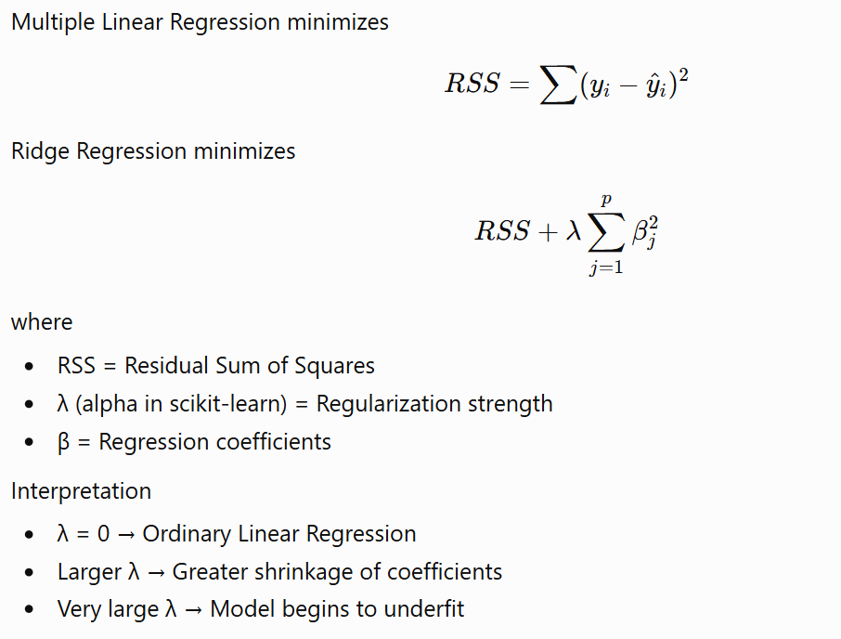
Characteristic | Effect
Scaling | Mandatory
Outliers | Sensitive
Missing Values | Must be handled before fitting
Categorical Variables | Must be encoded
Multicollinearity | Handles very well
Feature Importance | Shrunk coefficients
Interpretability | High (slightly reduced compared to OLS)
Computational Complexity | Similar to Multiple Linear Regression
Prediction Speed | Very fast

L1 regularization

Item | Description
Algorithm Type | Regression
Learning Type | Supervised
Target Variable | Continuous
Parametric | Yes
Linear / Non-linear | Linear
Regularization | L1 (Lasso Penalty)
Interpretability | High
Feature Selection | Yes
Main Objective | Reduce overfitting and automatically eliminate irrelevant predictors

While Ridge Regression shrinks all coefficients toward zero, Lasso Regression goes one step further by shrinking some coefficients exactly to zero.
This means Lasso performs automatic feature selection.
It is particularly useful when:
- There are many predictors.
- Some predictors are irrelevant.
- A simpler, more interpretable model is desired.
Think of Lasso as a regression model that simultaneously fits the data and selects the most important features.

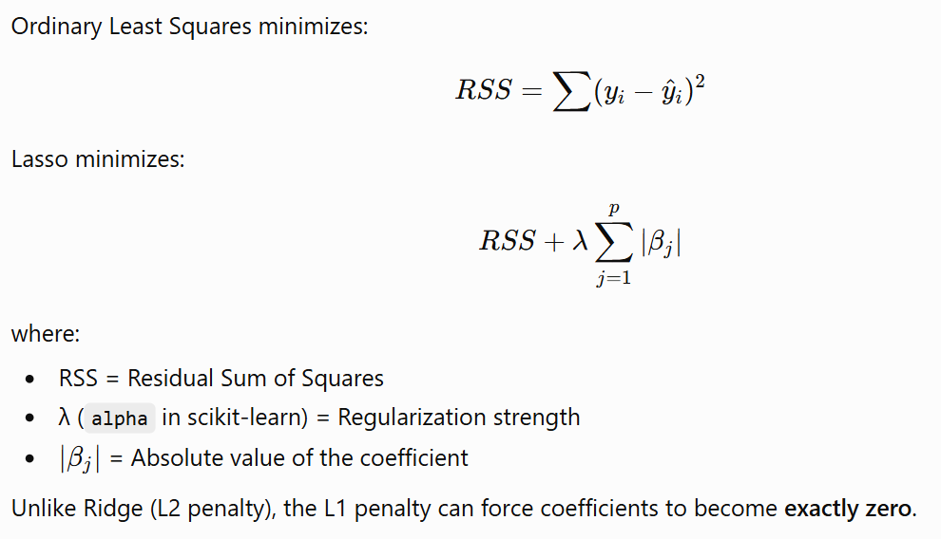
Characteristic | Effect
Scaling | Mandatory
Outliers | Sensitive
Missing Values | Must be handled before fitting
Categorical Variables | Must be encoded
Multicollinearity | Handles reasonably well but may arbitrarily select one correlated feature
Feature Importance | Coefficients (some become exactly zero)
Interpretability | Excellent
Computational Complexity | Slightly higher than OLS due to iterative optimization
Prediction Speed | Very fast

Elastic Net Regression

Item | Description
Algorithm Type | Regression
Learning Type | Supervised
Target Variable | Continuous
Parametric | Yes
Linear / Non-linear | Linear
Regularization | L1 + L2
Interpretability | High
Feature Selection | Yes
Main Objective | Combine Ridge and Lasso to improve prediction and feature selection, especially with correlated predictors

ElasticNet combines the strengths of Ridge Regression and Lasso Regression.
- Ridge shrinks coefficients.
- Lasso removes unimportant features.
- ElasticNet does both simultaneously.
It is particularly useful when:
- There are many predictors.
- Predictors are highly correlated.
- Some predictors are irrelevant.
- You want feature selection without arbitrarily discarding correlated variables.

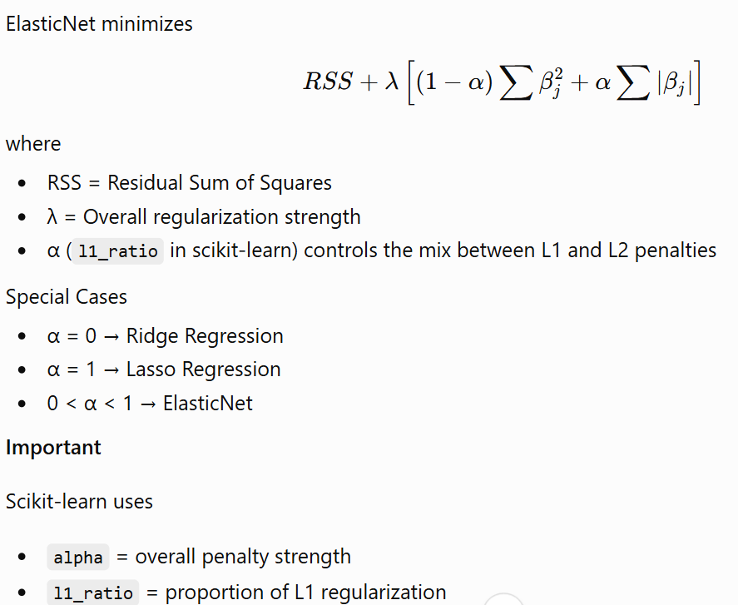

Characteristic | Effect
Scaling | Mandatory
Outliers | Sensitive
Missing Values | Must be handled before fitting
Categorical Variables | Must be encoded
Multicollinearity | Excellent handling
Feature Importance | Coefficients (some may become zero)
Interpretability | High
Computational Complexity | Slightly higher than Ridge and Lasso
Prediction Speed | Very fast

Binary logistic regression

Item | Description
Algorithm Type | Classification
Learning Type | Supervised
Target Variable | Binary (0/1, Yes/No, True/False)
Parametric | Yes
Linear / Non-linear | Linear Decision Boundary
Output | Probability (0–1)
Interpretability | Excellent
Feature Importance | Regression coefficients / Odds Ratios
Main Objective | Estimate the probability of belonging to a class

Unlike Linear Regression, which predicts a continuous value, Logistic Regression predicts the probability that an observation belongs to a particular class.
Examples:
- Will a customer churn?
- Will a patient have diabetes?
- Will a loan default?
- Is an email spam?
Instead of predicting "Yes" or "No" directly, Logistic Regression first predicts a probability

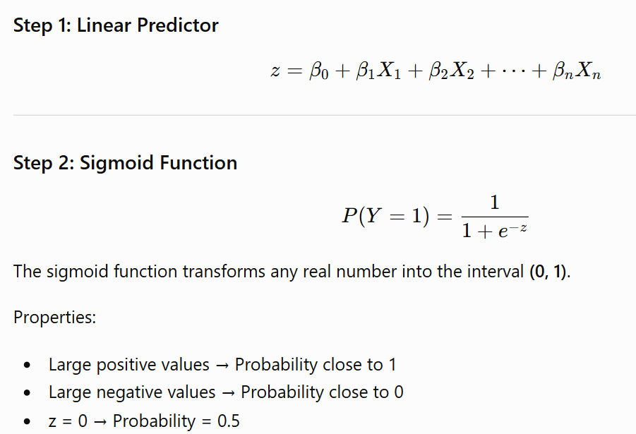
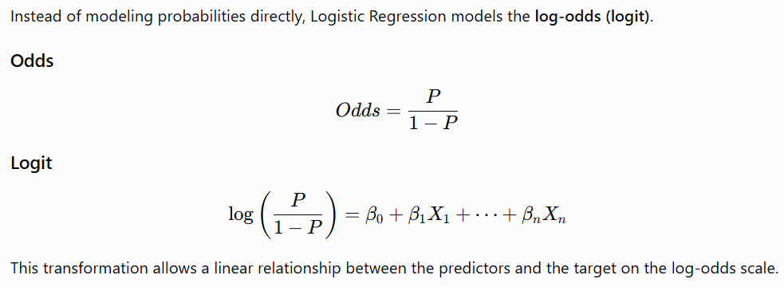

Linear Regression minimizes Residual Sum of Squares (RSS).
Logistic Regression instead uses Maximum Likelihood Estimation (MLE).
The objective is to find the coefficients that maximize the likelihood of observing the training data. Maximizing the MLE is by reducing the magnitude of log loss.

Characteristic | Effect
Scaling | Recommended (especially with regularization)
Outliers | Moderately sensitive
Missing Values | Must be handled before fitting
Categorical Variables | Must be encoded
Multicollinearity | Can affect coefficient stability
Feature Importance | Coefficients and Odds Ratios
Interpretability | Excellent
Computational Complexity | Efficient for moderate-sized datasets
Prediction Speed | Very fast

Overfitting
Causes
- Too many predictors.
- Small training datasets.
- High-dimensional feature space.

How to Reduce It
- Use L1 or L2 regularization.
- Reduce the number of predictors.
- Collect more data.

Metric | Formula | When Important
Accuracy | (TP+TN)/Total | Balanced datasets
Precision | TP/(TP+FP) | False positives are costly
Recall (Sensitivity) | TP/(TP+FN) | False negatives are costly
Specificity | TN/(TN+FP) | Correctly identifying negatives
F1-score | Harmonic mean of Precision and Recall | Imbalanced datasets
ROC-AUC | Area under the ROC curve | Threshold-independent model comparison
Log Loss | Penalizes incorrect probability estimates | Probability calibration

Decision tree

Item | Description
Algorithm Type | Classification / Regression
Learning Type | Supervised
Target Variable | Categorical or Continuous
Parametric | No
Linear / Non-linear | Non-linear
Interpretability | Excellent
Feature Importance | Yes
Handles Non-linearity | Yes
Main Objective | Recursively split the data into increasingly homogeneous groups

A Decision Tree mimics human decision-making by asking a sequence of questions
Is Age > 30?

Yes
|
Income > 8L ?

/ \
Yes No

Approve Reject

Each question divides the dataset into smaller subsets that become progressively more homogeneous.
The algorithm automatically determines:
- Which feature to split.
- Where to split.
- When to stop splitting.
The objective is to maximize the purity of each child node

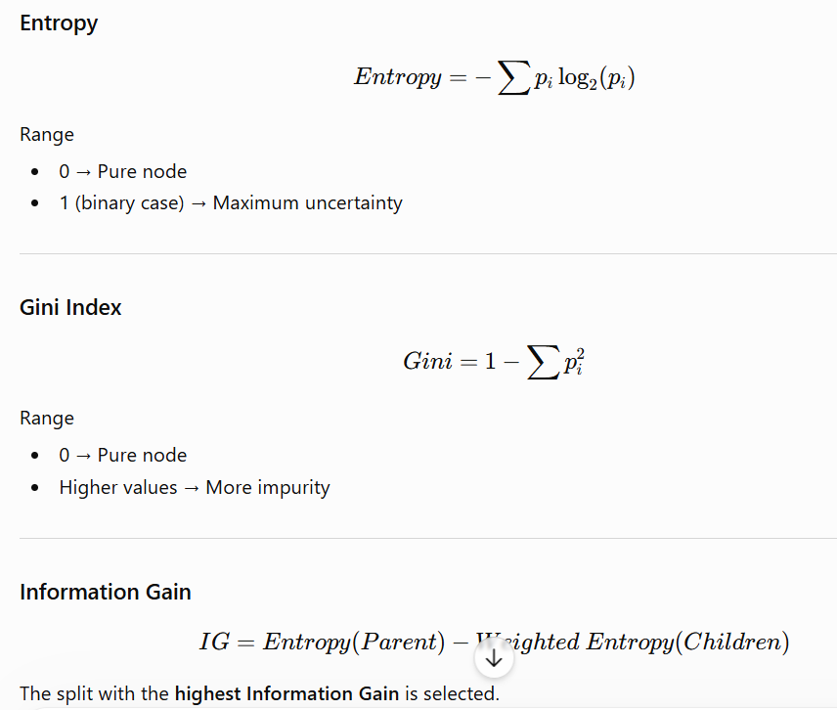

Characteristic | Effect
Scaling | Not Required
Outliers | Low sensitivity
Missing Values | Must be handled in scikit-learn before fitting
Categorical Variables | Must be encoded in scikit-learn
Multicollinearity | Not affected significantly
Feature Importance | Yes
Interpretability | Excellent
Prediction Speed | Very fast

Hyperparameter | Default | Recommended Starting Value | Purpose
criterion | "gini" (classifier) / "squared_error" (regressor) | Default | Split criterion
max_depth | None | 5–20 | Controls tree depth
min_samples_split | 2 | 5–20 | Minimum samples required to split a node
min_samples_leaf | 1 | 2–10 | Minimum samples in each leaf
max_features | None | "sqrt" (classification), or tune | Number of features considered at each split
ccp_alpha | 0.0 | 0–0.01 | Cost-complexity pruning parameter
random_state | None | 42 | Reproducibility

Decision Trees are highly prone to overfitting.
Causes
- Very deep trees.
- Small leaf sizes.
- Excessive branching.
- Noise in the training data.
How to Reduce It
- Limit max_depth.
- Increase min_samples_leaf.
- Increase min_samples_split.
- Use ensemble methods such as Random Forest or Gradient Boosting.

When to Use
- Non-linear relationships.
- Mixed feature types.
- Need a highly interpretable model.
- Moderate-sized datasets.
- Exploratory modeling and feature importance analysis.

RANDOM FOREST

Item | Description
Algorithm Type | Ensemble Learning
Learning Type | Supervised
Target Variable | Classification & Regression
Ensemble Method | Bagging (Bootstrap Aggregation)
Base Learner | Decision Tree
Parametric | No
Linear / Non-linear | Non-linear
Interpretability | Moderate
Feature Importance | Yes
Main Objective | Reduce variance by averaging predictions from many independent Decision Trees

A single Decision Tree is like asking one expert for an opinion.
Random Forest asks hundreds of experts, each trained on a slightly different version of the data.
Each tree:
- sees a different bootstrap sample
- considers only a random subset of features at each split
- makes its own prediction

The final prediction is obtained by:
Classification: Majority Voting
Regression: Average prediction

Characteristic | Effect
Scaling | Not Required
Outliers | Very Robust
Missing Values | Handle before fitting in scikit-learn
Categorical Variables | Encode before fitting in scikit-learn
Multicollinearity | Not significantly affected
Feature Importance | Yes
Interpretability | Moderate
Computational Complexity | Approximately O(Number of Trees × Tree Complexity)
Prediction Speed | Moderate

Hyperparameter | Default | Recommended Starting Value | Purpose
n_estimators | 100 | 300–500 | Number of trees
criterion | gini | Default | Split criterion
max_depth | None | 10–20 | Control overfitting
min_samples_split | 2 | 5–20 | Minimum samples before split
min_samples_leaf | 1 | 2–5 | Reduce overfitting
max_features | sqrt (classifier) | sqrt | Random feature selection
bootstrap | True | True | Bootstrap sampling
oob_score | False | True | Out-of-Bag validation
random_state | None | 42 | Reproducibility

Overfitting occurs when
- trees become extremely deep
- noisy predictors dominate
- training dataset is very small

Reduce Overfitting
- Limit tree depth
- Increase minimum leaf size
- Increase training data
- Remove noisy predictors

Gradient Boosting

Item | Description
Algorithm Type | Ensemble Learning
Learning Type | Supervised
Target Variable | Classification & Regression
Ensemble Method | Boosting
Base Learner | Decision Tree (usually shallow trees)
Parametric | No
Linear / Non-linear | Non-linear
Interpretability | Moderate
Feature Importance | Yes
Main Objective | Sequentially build trees that correct the errors made by previous trees

Unlike Random Forest, where all trees are built independently, Gradient Boosting builds trees sequentially.
Each new tree focuses on correcting the mistakes (residual errors) made by the previous ensemble.

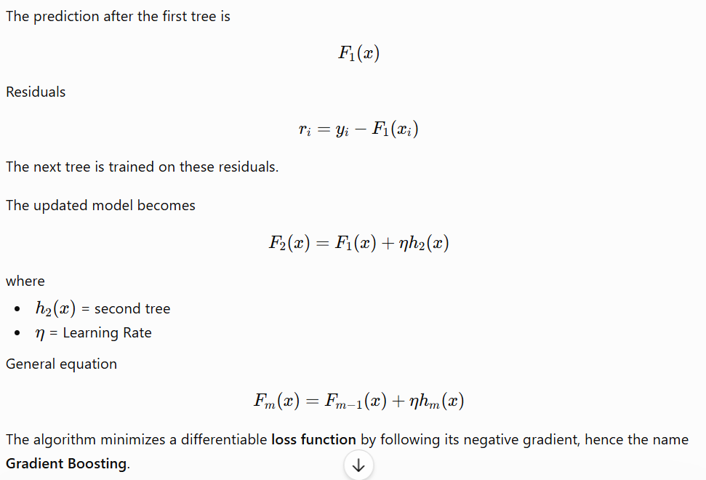

Characteristic | Effect
Scaling | Not Required
Outliers | Moderate sensitivity (depends on the chosen loss function)
Missing Values | Must be handled before fitting in scikit-learn
Categorical Variables | Must be encoded in scikit-learn
Multicollinearity | Not significantly affected
Feature Importance | Yes
Interpretability | Moderate
Training Speed | Slower than Random Forest
Prediction Speed | Moderate

Hyperparameter | Default | Recommended Starting Value | Purpose
n_estimators | 100 | 200–500 | Number of boosting stages
learning_rate | 0.1 | 0.03–0.1 | Step size for each new tree
max_depth | 3 | 3–6 | Depth of each tree
Subsample | 1.0 | 0.7–0.9 | Fraction of samples used per tree (stochastic boosting)
min_samples_split | 2 | 5–20 | Minimum samples to split
min_samples_leaf | 1 | 2–10 | Minimum samples per leaf
random_state | None | 42 | Reproducibility

Causes
- Too many trees.
- Large tree depth.
- High learning rate.
- Small datasets.
- Noisy data.

How to Reduce It
- Reduce learning_rate.
- Increase n_estimators while lowering learning_rate.
- Limit max_depth.
- Use subsample < 1.0.
- Apply early stopping where available.

Adaboost

Item | Description
Algorithm Type | Ensemble Learning
Learning Type | Supervised
Target Variable | Classification & Regression
Ensemble Method | Boosting
Base Learner | Decision Stump (Depth = 1) by default
Parametric | No
Linear / Non-linear | Non-linear
Interpretability | Moderate
Feature Importance | Yes
Main Objective | Sequentially improve performance by giving greater importance to previously misclassified observations

Imagine a teacher evaluating a class.
After the first test, the teacher notices that certain students performed poorly.
Instead of teaching the entire class again, the teacher spends more time with the weaker students.
AdaBoost follows the same philosophy.

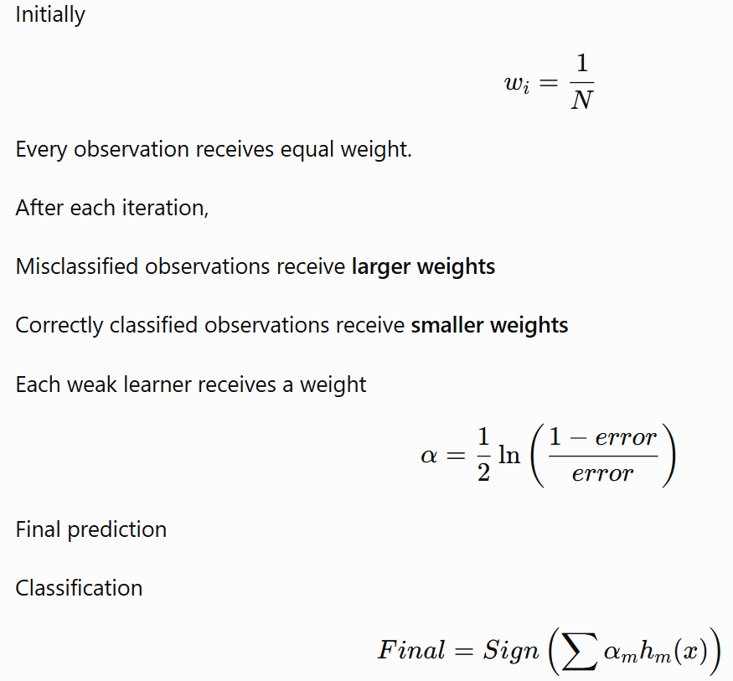
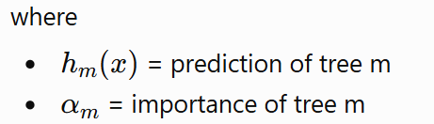

Characteristic | Effect
Scaling | Not Required
Outliers | Sensitive
Missing Values | Must be handled before fitting
Categorical Variables | Must be encoded in scikit-learn
Multicollinearity | Not significantly affected
Feature Importance | Yes
Interpretability | Moderate
Training Speed | Moderate
Prediction Speed | Fast

Hyperparameter | Default | Recommended Starting Value | Purpose
n_estimators | 50 | 100–300 | Number of weak learners
learning_rate | 1.0 | 0.05–0.5 | Contribution of each learner
estimator | Decision Stump | Decision Tree (Depth=1 or 2) | Base learner
random_state | None | 42 | Reproducibility

AdaBoost generally resists overfitting when using shallow trees.
However, overfitting may occur when
- Large trees are used.
- Too many estimators are added.
- Dataset contains noisy labels.
- Learning rate is too high.
Reduce Overfitting
- Use Decision Stumps.
- Reduce learning rate.
- Remove noisy observations.
- Tune n_estimators.

XGBoost

Gradient Boosting Problem | XGBoost Solution
Overfitting | L1/L2 Regularization
Slow training | Parallelized tree construction
Poor missing value handling | Native missing value support
Large trees | Tree pruning
Many parameters | Better optimization
First-order optimization | Second-order optimization

Instead of just saying "uses the Hessian," lets explain it intuitively:
- Gradient tells you the direction of improvement.
- Hessian tells you how sharply the loss function curves.
- XGBoost uses both to choose better splits.

Loss function: fits the data.
γ (gamma): discourages unnecessary tree splits.
λ (lambda): L2 regularization on leaf weights.
α (alpha): L1 regularization on leaf weights.

- Decision Tree → grows first, prunes later.
- XGBoost → grows only if the split improves the objective.
This is a major reason XGBoost is less prone to overfitting.

- During training, XGBoost learns the best default direction (left or right) for missing values at each split.
- During prediction, missing values follow that learned path.
This makes XGBoost more robust to missing data than many traditional tree implementations.

Algorithm | Main Idea | Biggest Weakness
Decision Tree | Single tree | Overfitting
Random Forest | Bagging | Larger models
Gradient Boosting | Residual learning | Slower, less regularized
AdaBoost | Reweight observations | Sensitive to noisy labels
XGBoost | Regularized gradient boosting | More hyperparameters

KNN Classifier/ Regressor  Item | Description
Algorithm Type | Classification / Regression
Learning Type | Supervised
Target Variable | Categorical or Continuous
Parametric | No
Linear / Non-linear | Non-linear
Lazy / Eager Learner | Lazy Learner
Interpretability | High
Feature Importance | No
Main Objective | Predict using the labels or values of the nearest neighbors

KNN is one of the simplest Machine Learning algorithms.
It follows a very intuitive principle:
"Similar observations tend to have similar outcomes."
Unlike most algorithms, KNN does not build a mathematical model during training.
Instead, it simply stores the training data.
When a new observation arrives:
- Calculate the distance from the new observation to every training point.
- Identify the K nearest neighbors.
- Use those neighbors to make the prediction.

Classification: majority vote
Regression: average

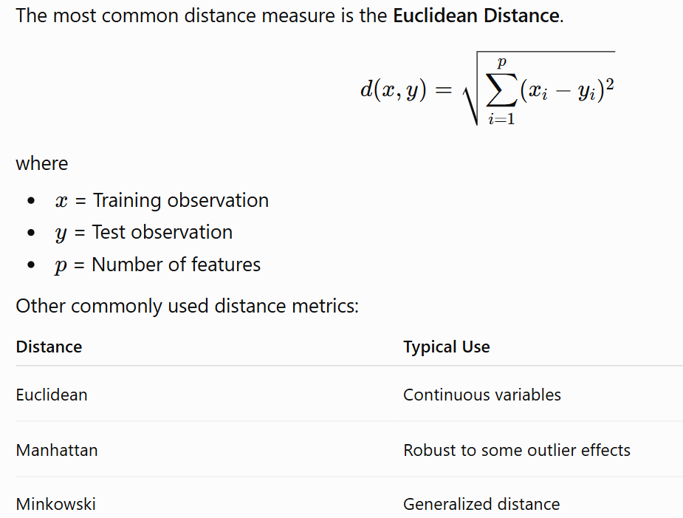

Characteristic | Effect
Scaling | Mandatory
Outliers | Highly Sensitive
Missing Values | Must be handled before fitting
Categorical Variables | Must be encoded
Multicollinearity | Usually not a major issue
Feature Importance | Not available directly
Interpretability | High
Training Speed | Extremely Fast (stores data)
Prediction Speed | Slow (distance calculations)

A small value of K makes the model highly sensitive to individual observations and results in overfitting
A large value of K smooths the decision boundary too much and results in underfitting

Support Vector Machines

Item | Description
Algorithm Type | Classification / Regression
Learning Type | Supervised
Target Variable | Categorical or Continuous (SVR)
Parametric | No
Linear / Non-linear | Both
Interpretability | Moderate
Feature Importance | No (not directly)
Handles High Dimensions | Excellent
Main Objective | Find the decision boundary with the maximum margin between classes

SVM asks:
Which separating boundary is the safest?
Instead of choosing any separating line,
SVM chooses the one that leaves the largest possible gap between the two classes.
That gap is called the Margin.
A larger margin generally leads to better generalization on unseen data.

Hyperplane
The decision boundary separating the classes.

Margin
The distance between the hyperplane and the nearest observations.
SVM tries to maximize this margin.

Support Vectors
These are the observations closest to the decision boundary.
They determine the location of the hyperplane.
If all other observations are removed, the decision boundary changes very little.
If the support vectors move, the boundary changes.
Hence the name Support Vector Machine.

Characteristic | Effect
Scaling | Mandatory
Outliers | Moderately sensitive (controlled by C)
Missing Values | Must be handled before fitting
Categorical Variables | Must be encoded
Multicollinearity | Usually not a major issue
Feature Importance | Not directly available
Interpretability | Moderate
Training Speed | Slow for very large datasets
Prediction Speed | Moderate

Hyperparameter | Default | Recommended Starting Value | Purpose
kernel | "rbf" | "rbf" (general), "linear" (high-dimensional sparse data) | Type of decision boundary
C | 1.0 | 0.1–10 | Controls margin vs. training error
gamma | "scale" | "scale" (good default) or tune | Controls influence of individual observations
degree | 3 | 2–4 (Polynomial kernel only) | Polynomial degree
coef0 | 0.0 | Default | Independent term for polynomial/sigmoid kernels

Overfitting
Causes
- Very large C
- Very high gamma
- Polynomial degree too large
- Small training dataset
How to Reduce It
- Reduce C
- Reduce gamma
- Scale features
- Use cross-validation
- Start with the RBF kernel before experimenting with others

Naïve Bayes Classifier

Item | Description
Algorithm Type | Classification
Learning Type | Supervised
Target Variable | Categorical
Parametric | Yes
Linear / Non-linear | Linear Decision Boundary (varies by variant)
Probabilistic | Yes
Interpretability | High
Feature Importance | No (indirectly through conditional probabilities)
Main Objective | Predict the class with the highest posterior probability using Bayes' Theorem

Naive Bayes predicts the probability that an observation belongs to each class and chooses the class with the highest posterior probability.
It is based on a simple assumption:
All predictor variables are conditionally independent given the class.

Characteristic | Effect
Scaling | Recommended for Gaussian NB when feature scales differ substantially (not mandatory)
Outliers | Moderately sensitive (especially Gaussian NB)
Missing Values | Must be handled before fitting
Categorical Variables | Encode appropriately or use suitable NB variant
Multicollinearity | Performance may degrade because predictors are assumed independent
Feature Importance | Not directly available
Interpretability | High
Training Speed | Extremely Fast
Prediction Speed | Extremely Fast

K Means clustering

Item | Description
Algorithm Type | Clustering
Learning Type | Unsupervised
Target Variable | None
Parametric | No
Linear / Non-linear | Distance-based
Cluster Type | Partition-based
Interpretability | Moderate
Feature Importance | No
Main Objective | Partition observations into K clusters such that observations within a cluster are as similar as possible

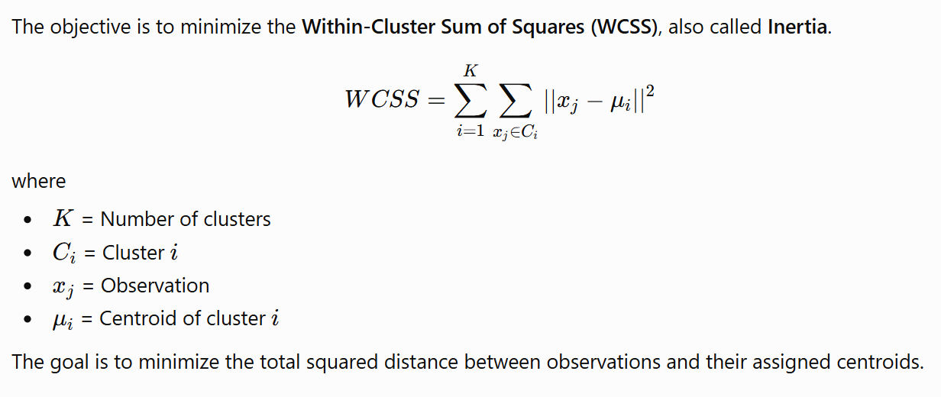

Characteristic | Effect
Scaling | Mandatory
Outliers | Highly Sensitive
Missing Values | Must be handled before fitting
Categorical Variables | Not supported directly (numeric data required)
Multicollinearity | Usually not a major issue
Feature Importance | Not available
Interpretability | Moderate
Training Speed | Very Fast
Prediction Speed | Very Fast

Overfitting
Although clustering is unsupervised, choosing an excessively large K can produce clusters that model random noise rather than meaningful structure.
Avoid Overfitting
- Use the Elbow Method.
- Use the Silhouette Score.
- Validate clusters using domain knowledge.
- Compare multiple values of K rather than relying on a single run.

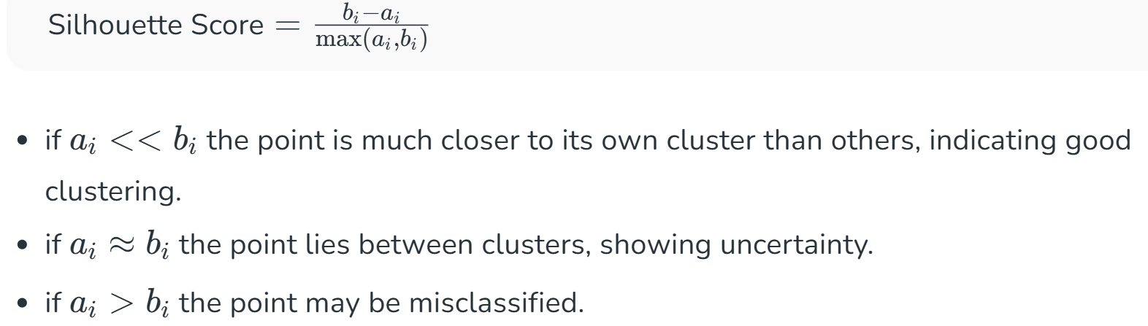
- Intra-cluster distance ($a_{i}$): This is the average distance between the data point and all other points in the same cluster. A smaller value indicates the point is closely aligned with its cluster.
- Nearest-cluster distance ($b_{i}$): This is the average distance between the data point and all points in the nearest neighbouring cluster (the next best alternative). A larger value means the point is well-separated from other clusters.
